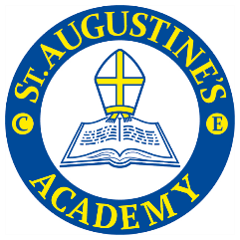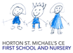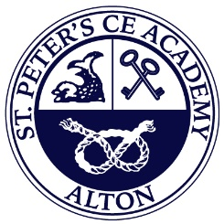

The Saints Academies Assessment Policy 2024-25

Philosophy
All children have a right to an education that offers equal opportunity and an inclusive curriculum in a community which develops sensitivity to differences. We believe that, through our approach to assessment, we can raise standards and help children to recognise their own strengths and areas for development. Each child is encouraged and supported to achieve spiritually, socially and academically, within the Christian church school ethos of love and respect for all.
Aims
We aim to:
- Provide the highest quality of teaching and learning for our school community.
- Develop, encourage, support and challenge each child to achieve their potential.
Using the principles of assessment we aim to:
- Monitor progress and support learning.
- Recognise the achievements of children.
- Guide future planning, teaching and curriculum development.
- Inform parents and the wider community of children’s achievement.
- Provide information to ensure continuity when a child changes year group or school.
- Comply with statutory requirements.

We will promote Assessment for Learning, a continuous process which involves the seeking and interpreting of evidence for use by the children and their teachers. Assessment for Learning helps to decide where the children are in their learning, where they need to go next and what is the best way to get there.
- We will support children and provide feedback, so that they recognise the next steps in their learning.
- We will involve children in self-assessment and peer assessment, with appropriate support.

Guidelines
We will use the following strategies in our classrooms:
- Clarify learning objectives at the planning stage so that formative assessment can take place in the classroom.
- Share learning outcomes (steps to success) with the children at the beginning of each lesson and refer to them at appropriate times throughout the lesson.
- Focus appropriate oral and written feedback around the learning objectives of lessons and activities and provide children with the opportunity to reflect on the feedback and support them in achieving the learning they are aiming for.
- Organise individual, group and whole class target setting where appropriate, in order that children’s achievements and targets are based on previous learning as well as aiming for the next level of learning.
- Use appropriate questioning to give children the opportunity to clarify their learning and help to raise their confidence and self esteem through praise and celebration of success.

Monitoring
Pupil progress will be monitored at least termly by teaching staff and SLT and will be reported to parents termly through parents’ evenings and at the end of the academic year with a school report. Children with SEND will be highlighted in the A3 tracking book and monitored by the SENCo. Pupil Progress meetings are held termly to ensure early intervention with those children not on track to make at least expected progress.
Agreed: September 2024

Review Summer 2025

Appendix

Moderation
The process of moderation is an essential part of the assessment system. Teachers are involved in the moderation process to ensure agreement on criteria for levels:
- With colleagues in school.
- With colleagues from other schools.
- Via subject leader book trawls.
- Attending SUAT sessions to ensure judgements are in line with other schools.
- Using nationally available exemplification materials.
Reporting
- Reports promote and support good home/school relationships.
- They provide information for parents and an opportunity for discussion with parents.
- Written reports will be sent to parents at the end of the school year. Comments on attainment and progress are made and next steps. Parents will be invited to attend formal discussions on pupil progress each term, however, parents are welcome to discuss pupil progress at any time, should the need arise.
Records
Teachers use records to review pupils’ progress and set appropriate targets. Evidence for record keeping may include:
- Planning
- Children’s work
- Notes on outcomes
- Marking and feedback
- School based progression documents matched to the end of year expectations.
- Assessment observations
- Progression documents for History and Geography.
- End of year reports
- EYFS Profile – children enter Foundation with a ‘Learning Journey’ record from any preschool attended – results are used to inform planning, set targets and aid early identification of SEN. Children are observed regularly and annotated photographs, children’s work provide evidence of learning and achievement.

